Titanic Dataset Analysis

Name
Professor Name
University Affiliation
Course Number
Date

Introduction
Developing a model to predict survival rate in the Titanic dataset is a classic example of a binary classification problem. The goal of this task is to build a model that can accurately predict whether a given passenger survived or not, based on a set of input features such as age, gender, passenger class, and so on.
To tackle this task, we would typically start by performing exploratory data analysis to gain a better understanding of the dataset and to identify any patterns or relationships between the different features and the target variable (i.e., survival). We might also need to clean and preprocess the data, filling in missing values, encoding categorical variables, and scaling numerical features, depending on the specific requirements of the machine learning algorithm we plan to use.
Once the data is cleaned and preprocessed, we can start building and training our predictive model. There are many machine learning algorithms that can be used for binary classification tasks, including logistic regression, decision trees, random forests, support vector machines (SVMs), and neural networks, among others. The choice of algorithm will depend on various factors such as the size and complexity of the dataset, the nature of the features, and the performance requirements of the model.
After training our model, we would typically evaluate its performance on a held-out test set, using metrics such as accuracy, precision, recall, and F1 score to measure its performance. We might also perform cross-validation to get a more robust estimate of the model's performance and to tune its hyperparameters.

Objective
The objective of this project is to understand the factors that contribute to the survival of the Titanic accident and to build a model in Alteryx to estimate the survival probability of passengers. In more detail we will:
- Perform data cleaning and validation techniques to prepare data for analysis.
- Analyse resulting dataset to discover correlations between features and compare different passenger groups.
- Build a model to estimate survival probability of Titanic passengers.

Description of titanic dataset
The Titanic dataset is a popular dataset that contains information about the passengers who were aboard the Titanic during its ill-fated maiden voyage, which sank after hitting an iceberg in the North Atlantic Ocean on April 15, 1912. The dataset includes various attributes of each passenger, such as their age, gender, passenger class, fare paid, cabin number, port of embarkation, and whether or not they survived the disaster.
The Titanic dataset contains a total of 12 features or columns, including:
- PassengerId: A unique identifier assigned to each passenger.
- Survived: A binary variable indicating whether the passenger survived the disaster or not (0 = No, 1 = Yes).
- Pclass: The passenger class, with three possible values (1 = 1st class, 2 = 2nd class, 3 = 3rd class).
- Name: The name of the passenger.
- Sex: The gender of the passenger (male or female).
- Age: The age of the passenger in years.
- SibSp: The number of siblings and/or spouses that the passenger was traveling with.
- Parch: The number of parents and/or children that the passenger was traveling with.
- Ticket: The ticket number.
- Fare: The fare paid for the ticket.
- Cabin: The cabin number.
- Embarked: The port of embarkation, with three possible values (C = Cherbourg, Q = Queenstown, S = Southampton).
These features provide a rich set of information about each passenger, including their demographic information, family relationships, and socio-economic status. They can be used to explore patterns and relationships between different variables, and to develop predictive models for survival during the disaster.
There are two datasets, train and test datasets for training, testing and predicting purposes. These are obtained from kaggle. The third dataset contains all the passengers who were aboard the titanic.Here is a brief inspection of the train dataset.
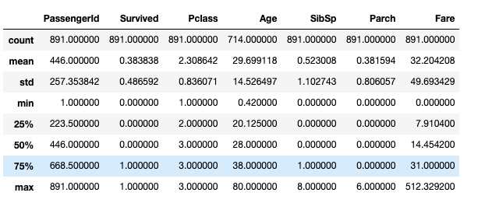

Let us look at the data row-wise and try to understand.
Count: The first-row ‘count’ is the number of entries in that particular column ‘PassengerID’. It shows 891(equal to the number of passengers), which means ‘PassengerID’ is available for all the passengers. Except ‘Age’, all other data are available for each passenger. We gotta do something to fix the missing values in the ‘Age’ column.
Mean: Mean of all data. Let's consider the ‘Fare’ column. The average ‘Fare’ of the passenger is USD 32.20
Std: Standard deviation of all data. A low standard deviation means that most of the numbers are close to the average, while a high standard deviation means that the numbers are more spread out. Again ‘Fare’ has a high standard deviation.
Min: Minimum value of the column. For example, the lowest ‘Fare’ shows USD 0, which means ‘Fare’ is unavailable for some passengers. The model may not perform well with 0 for some passengers. Hence we will need to focus on the ‘Fare’ column before modeling.
Max: Maximum value of the column. For example, the highest ‘Fare’ shows USD 512.33. The mean of the ‘Fare’ column says USD 32.20. We see there is a huge difference in fare. It could be because of the ‘Pclass’ they were traveling.
25%, 50% & 75%: 1st, 2nd, and 3rd quartile of the data. Quartile in statistics is a type of quantile that divides the number of ordered data points into four equal groups. 1st quartile is the middle number between the smallest number and the median. 2nd quartile is the median of the dataset. 3rd quartile is the middle value between the median and the highest value.

Entity Relationship Diagram of the dataset
An ERD (Entity Relationship Diagram) is a visual representation of the relationships between different entities or objects in a database. It is used to model the data and relationships in a database and to identify the key entities, attributes, and relationships between them.
In the Titanic dataset, the main entity is the passenger, and the attributes (or columns) represent different aspects of each passenger, such as their age, gender, passenger class, and survival status. The following is an example of how some of the attributes in the Titanic dataset might be related in an ERD:
- Passenger entity: This would be the main entity in the ERD, representing each individual passenger in the dataset.
- Age attribute: This attribute would be a simple attribute of the Passenger entity, indicating the age of each passenger.
- Gender attribute: This attribute would also be a simple attribute of the Passenger entity, indicating the gender of each passenger.
- Passenger class attribute: This attribute would also be a simple attribute of the Passenger entity, indicating the passenger class of each passenger.
- Survived attribute: This attribute would be a simple attribute of the Passenger entity, indicating whether each passenger survived or not.
- Siblings/Spouses attribute: This attribute would be a relationship attribute, indicating the number of siblings and/or spouses that each passenger was traveling with.
- Parents/Children attribute: This attribute would also be a relationship attribute, indicating the number of parents and/or children that each passenger was traveling with.
By modeling the Titanic dataset in an ERD, it becomes easier to understand the relationships between different attributes and how they are related to each other. This can be useful for analyzing the data and identifying patterns or insights that might not be immediately apparent from looking at the raw data.
Here are some ERD diagrams of the dataset:

ERD 1

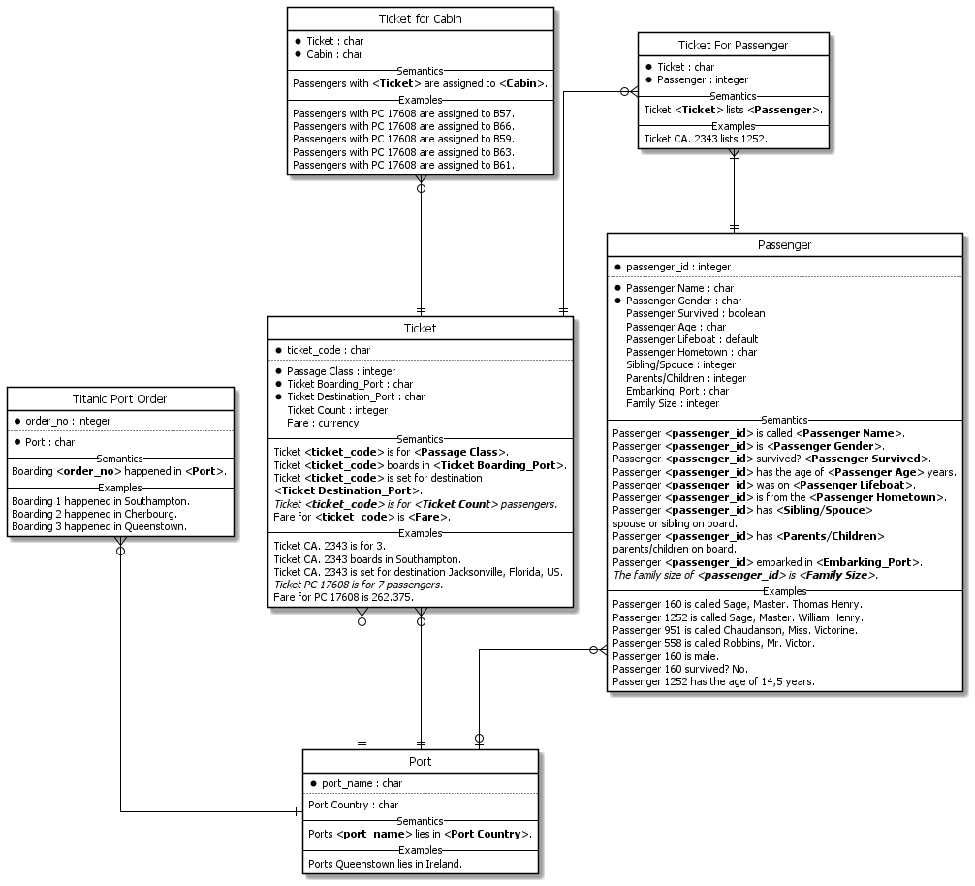

ERD 2

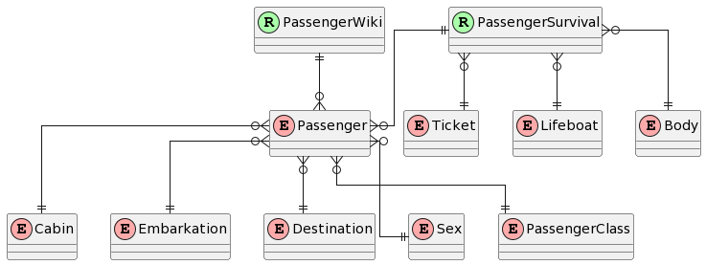

ERD 3

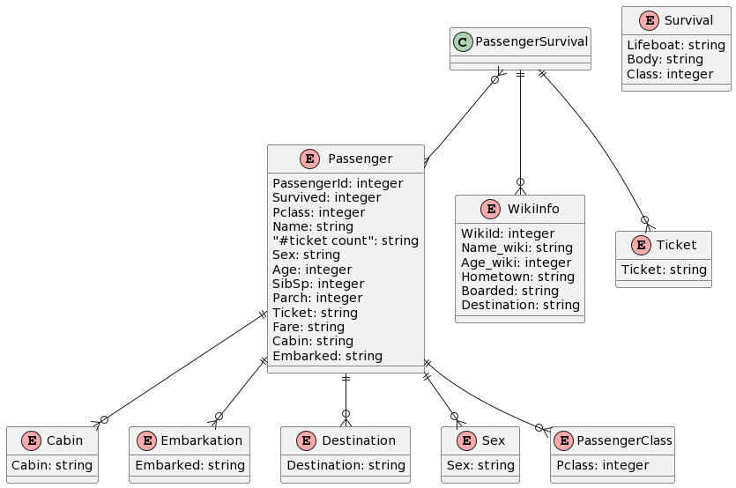

Tableau Visualizations
The Titanic data is imported then the wrangling of the data is done in Tableau. Then various objectives are fulfilled with the help of gears and functionalities provided by Tableau.
Overview of data
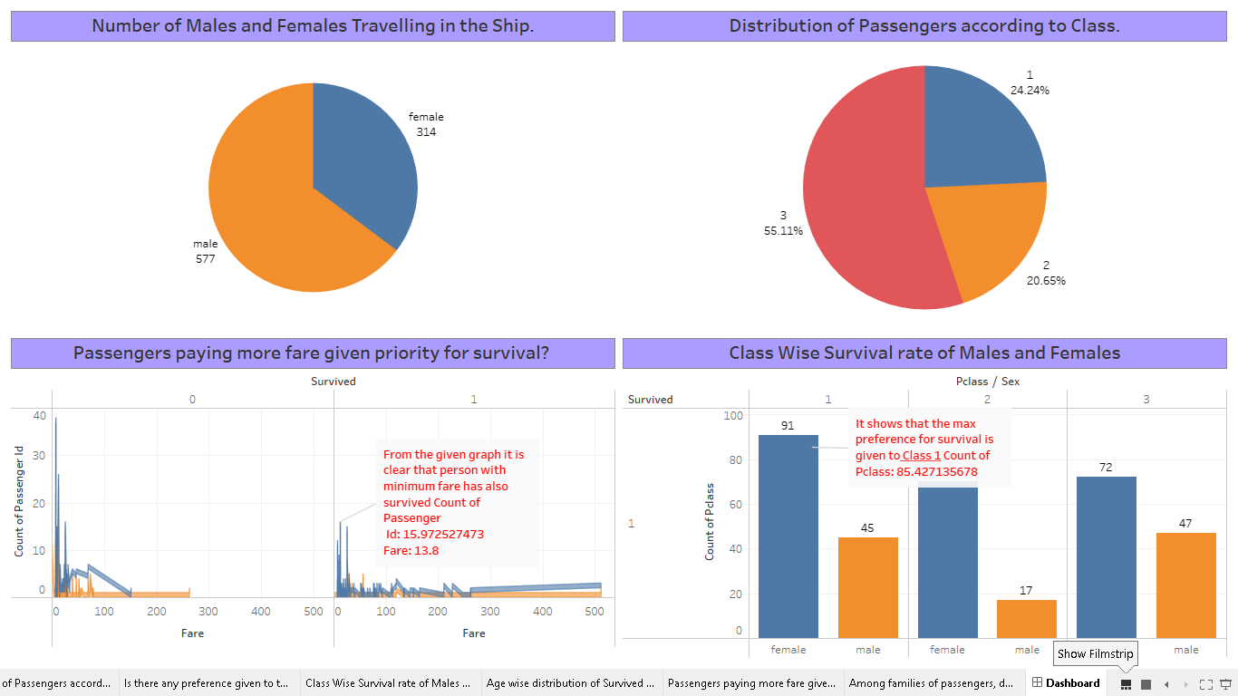

Number of males and females travelling in the ship

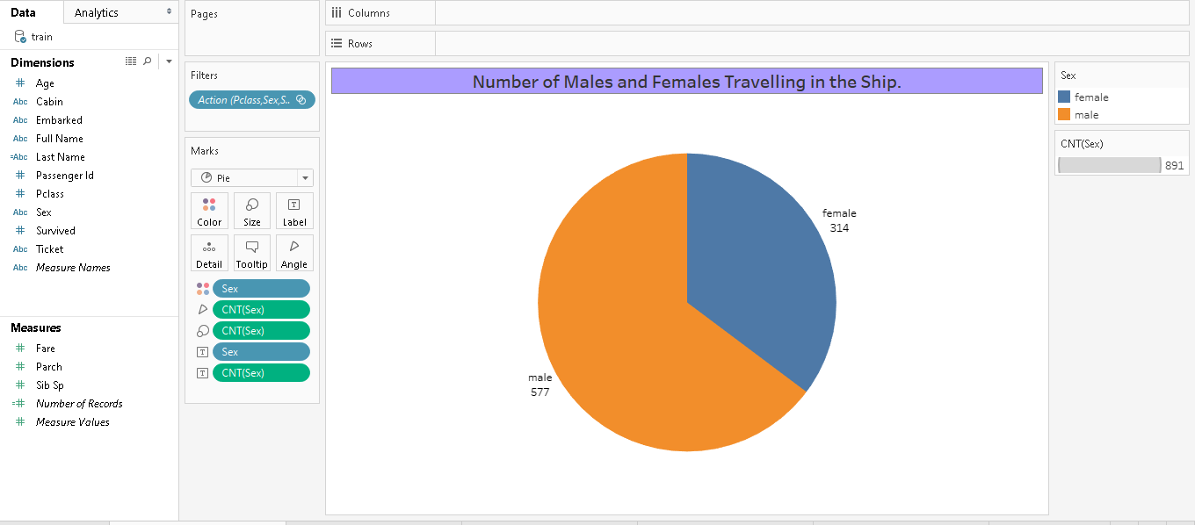

Gender preference in surviving

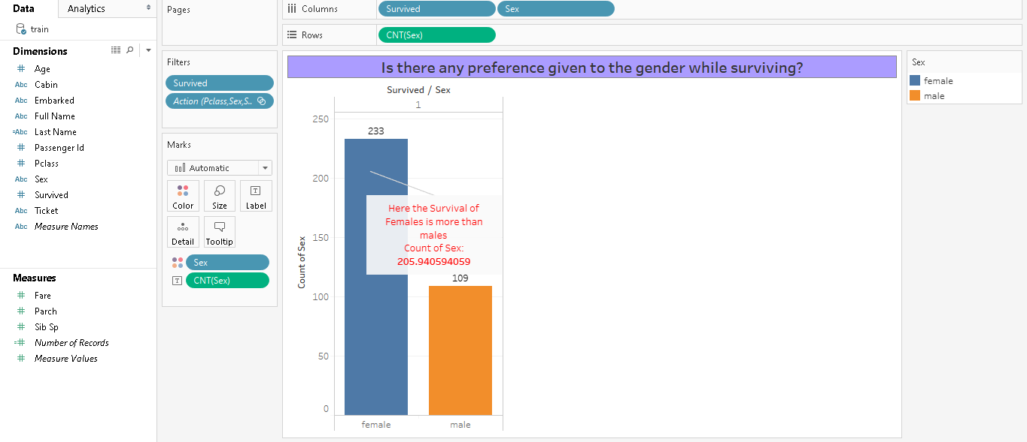

Distribution of passengers according to class

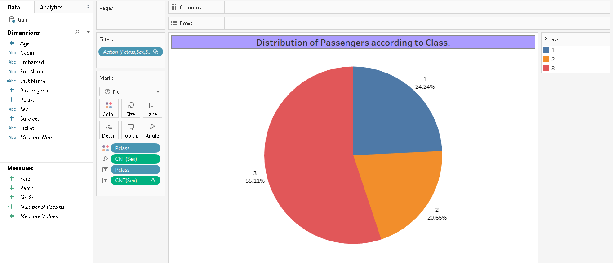

Class wise survival of males and females

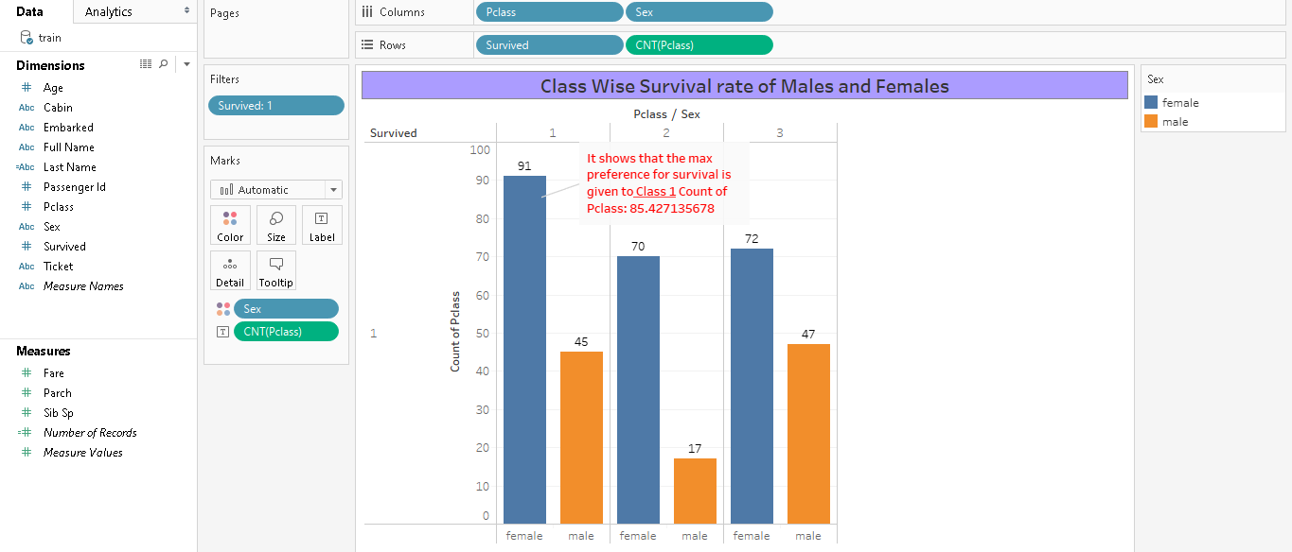

Age wise distribution of survived males and females

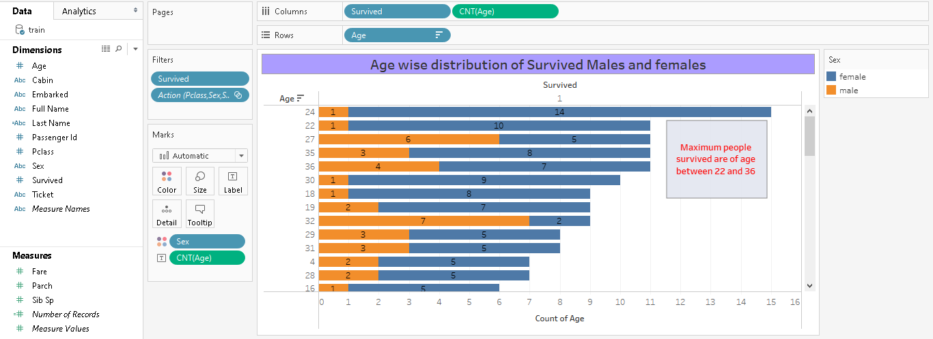

Passengers paying more fare given priority for survival?

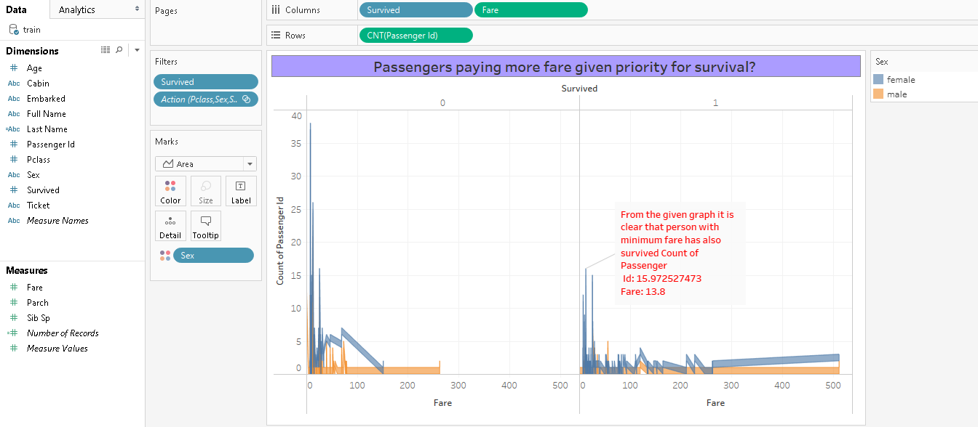

Data processing
Data processing on the Titanic dataset in Alteryx using can be accomplished and is tantamount. By using Alteryx, we can take advantage of its powerful data processing and analysis capabilities while still its leveraging the drag-and-drop interface to build and execute your workflows. This allows us to create more sophisticated and powerful data processing pipelines for the Titanic dataset and other datasets as well.
The objective of this project is to understand the factors that contribute to the survival of the Titatic accident and to build a model to estimate the survival
probability of passengers. In more detail we will:
- Perform data cleaning and validation techniques to prepare data for analysis.
- Analyse resulting dataset to discover correlations between features and compare different passenger groups.
- Build a model to estimate survival probability of Titanic passengers

Alteryx Workflows
Alteryx workflows are used for modelling.
Titanic Solved Classification

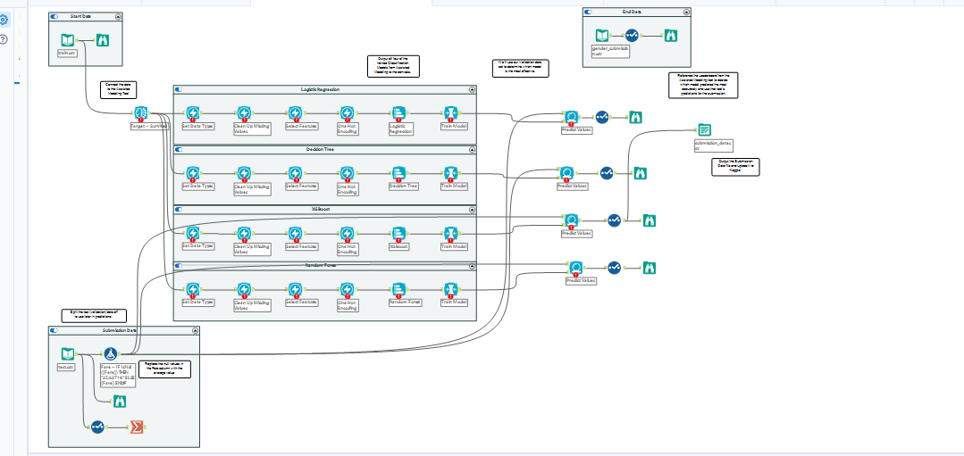

Titanic Starting Workflow

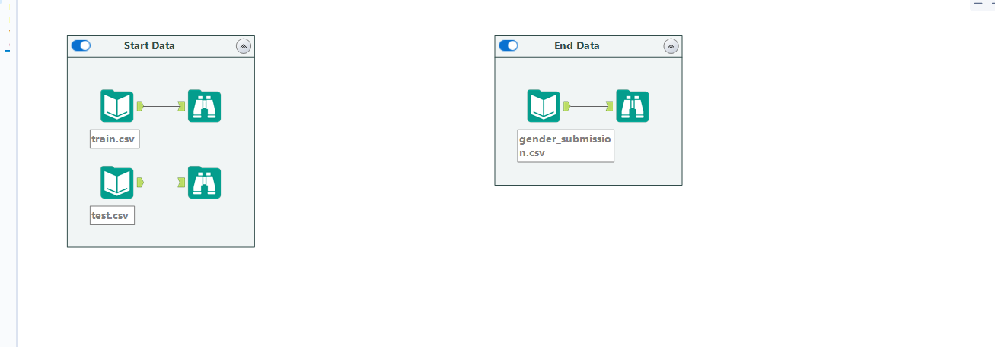

Titanic Solved Regression

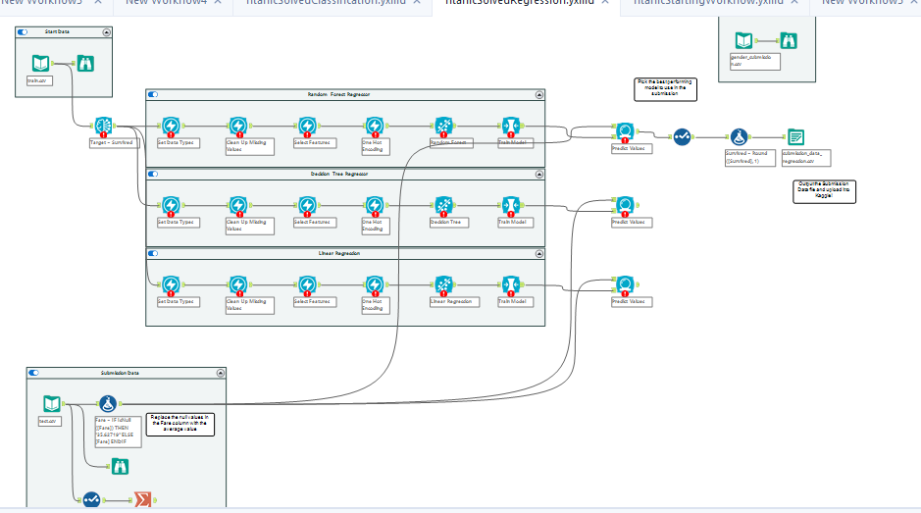

Further data analysis in R and the Results

Objective
The objective of the analysis is two-fold: first we will investigate associations between the variables with the target attribute Survived. This analysis will help us decide which models to build afterwards.
Since we have both numerical and categorical attributes and the target attribute is categorical, we will use the corresponding p-value from a One-Way ANOVA test to test significance between continuous variables and the target attribute and the p-value from a chi-squared test to test significance between categorical variables and the target attribute.
The null hypothesis for the One-Way ANOVA test is that all group produce the same variation on the response, on average. The null hypothesis for the chi-squared test is that the two variables are independent.

Normality and homogeneity of variance
First of all, we will test the numerical attributes “Age” and “Fare” for normality using the Shapiro-Wilk test and the homogeneity of the variance using Fligner-Killeen Test.
numeric_attr <- c("Age", "Fare")
#Shapiro-Wilk test
shapiro.wilk <- sapply(train[numeric_attr], function(x){shapiro.test(x)$p.value})
#Fligner-Killeen Test for homogeneity of variance
homogeneity_variance <- function(attr_name, dataset, target_name){
fligner.test(as.formula(paste(attr_name, target_name, sep="~")), data=dataset)$p.value
}
fligner <- sapply(numeric_attr, homogeneity_variance, dataset=train, target_name="Survived")
kable(rbind(shapiro.wilk, fligner), format="pandoc", digits=4)

Age Fare

shapiro.wilk 0.0000 0
fligner 0.1914 0

We can see that none of the variables appear to be normally distributed and that the attribute Fare does not have equal variances when grouped by the target value.

Association with target variable
Now we can finally explore the association between variables, specifically which variables are associated with the target attribute Survived. This will hint on which variables can be more informative during model building.
First we will graphically display the association between the variables and the target variable.

par(mfrow=c(3,3))
plot(train$Pclass, train$Survived, xlab="Pclass", ylab="Survived") plot(train$Sex, train$Survived, xlab="Sex", ylab="Survived") boxplot(Age~Survived, data=train, xlab="Survived", ylab="Age") boxplot(SibSp~Survived, data=train, xlab="Survived", ylab="SibSp") boxplot(Parch~Survived, data=train, xlab="Survived", ylab="Parch") boxplot(Fare~Survived, data=train, xlab="Survived", ylab="Fare") plot(train$Embarked, train$Survived, xlab="Embarked", ylab="Survived") plot(train$Title, train$Survived, xlab="Title", ylab="Survived") boxplot(FamilySize~Survived, data=train, xlab="Survived", ylab="FamilySize")

1 2 3 female male 0 1
Survived
0
0.0 1.0
Survived
0
0.0 1.0
Age
0 60

Pclass
Sex
Survived


0 1 0 1 0 1
SibSp
0 6
Parch
0 4
Fare
0 500

Survived
Survived
0.0 1.0
Survived
0.0 1.0
FamilySize
2 8
Survived
Survived


C Q | S | Master | Mr | Mrs | 0 | 1
 | Embarked |  | Title |  | Survived

Some of the insights that we can get from these plots are:
0
0
- The higher the class the better the changes of survival.
- Women survived more than men.
- Medium size families seem to have better survival chances than passengers who travel alone. The largest families seem to have a lower chance of survival.
- People who paid higher fares have more chances of survival (probably correlated with higher class).
- Passengers who embarked from Cherbourg seem to have better chances of survival.
- Passengers with a title of Master have a higher chance of survival than men with a title of Mr.
Since some of the groups have unequal variances we will be using the Welch ANOVA test that does not assume equal variances between groups. Additionally, we can use this parametric test because we have large sample sizes, even though we have seen they are not normally distributed. An alternative would be to use a non-parametric test such as the Kruskal-Wallis test.
To account for the effect sizes of the associations we are going to use the Intraclass correlation (continuous variables) and Cramer’s V (categorical variables). The first ranges between -1 (perfect anticorrelation) to 1 (perfect correlation) having absence of correlation a value of 0, while the latter ranges from 0 (no correlation) to 1 (perfect correlation).

cramer.v <- function(x, y){
as.numeric(sqrt(chisq.test(x, y)$statistic /
(length(x) * (min(length(unique(x)),length(unique(y))) - 1))))
}
compute_corr <- function(attr_name, dataset, target_name){
if(is.numeric(dataset[[attr_name]])){
pvalue <- oneway.test(as.formula(paste(attr_name, target_name,
sep="~")), data=dataset)$p.value
effect_size <- ICCest(target_name, attr_name, data=dataset)$ICC
} else { #it is factor
pvalue <- chisq.test(dataset[[attr_name]], dataset[[target_name]])$p.value effect_size <- cramer.v(dataset[[attr_name]], dataset[[target_name]])
}
list(pvalue=round(pvalue,digits=4), effect_size=round(effect_size,digits=4))
}

kable(t(sapply(names(train[-ncol(train)]), compute_corr, dataset=train, target_name="Survived")), format="pandoc")

 | pvalue | effect_size
Pclass | 0 | 0.3398
Sex | 0 | 0.5409
Age | 0.1191 | 0.0036
SibSp | 0.2327 | 3e-04
Parch | 0.0134 | 0.0116
Fare | 0 | 0.1283
Embarked | 0 | 0.1707
Title | 0 | 0.5671
FamilySize | 0.5853 | -0.0018

We can see that for all variables except Age, SibSp and FamilySize the results are significant at a 95% confidence level, that is those variables are associated with the target attribute Survived although the strength of such association is not very strong, as shown in the effect_size column, where the highest values are sligthly higher than 0.5. Therefore, there is not a very strong association between those variables and the target variable.

Model building
Now that we understand the association between the atributes and the response variable, we will propose several models to predict the target class. Since we are interested in models that output the probability of survival, we will use logistic regression models with different attributes as models.
First we will inspect a model with all variables that turned out significant in the previous analysis. That is, a model that related Survived with Pclass, Sex, Parch, Fare, Embarked and Title.
m1 <- glm(Survived ~ Pclass + Sex + Parch + Fare + Embarked + Title, family=binomial(link='logit'), data=train)
summary(m1)

##
## Call:
## glm(formula = Survived ~ Pclass + Sex + Parch + Fare + Embarked + ## Title, family = binomial(link = "logit"), data = train)
##
## Deviance Residuals:
## Min 1Q Median 3Q Max ## -2.4623 -0.6341 -0.3660 0.6170 2.3451 ##
## Coefficients
## Estimate Std. Error z value Pr(>|z|)
## | (Intercept) | 18.257723 | 437.522408 | 0.042 | 0.966714
## | Pclass2 | -0.835196 | 0.297943 | -2.803 | 0.005060
## | Pclass3 | -1.993777 | 0.286341 | -6.963 | 3.33e-12
## | Sexmale | -15.257644 | 437.522134 | -0.035 | 0.972181
## | Parch | -0.461983 | 0.129339 | -3.572 | 0.000354
## | Fare | 0.001793 | 0.002334 | 0.768 | 0.442382
## | EmbarkedQ | -0.269478 | 0.384326 | -0.701 | 0.483197
## | EmbarkedS | -0.603872 | 0.241278 | -2.503 | 0.012321
## | TitleMiss | -15.327244 | 437.522307 | -0.035 | 0.972054
## | TitleMr | -3.086177 | 0.405979 | -7.602 | 2.92e-14
## | TitleMrs | -14.844836 | 437.522339 | -0.034 | 0.972934
## | TitleOther | -3.460938 | 0.679286 | -5.095 | 3.49e-07
## | ---

**
***
***

*
***
***

## Signif. codes: 0 '***' 0.001 '**' 0.01 '*' 0.05 '.' 0.1 ' ' 1 ##
## (Dispersion parameter for binomial family taken to be 1) ##
## Null deviance: 1186.66 on 890 degrees of freedom ## Residual deviance: 755.39 on 879 degrees of freedom ## AIC: 779.39
##
## Number of Fisher Scoring iterations: 13
From the coefficients of the obtained model, we see that the coefficients for the atributes Fare, Sex and some of the categories in Title and Embarked are not significant at a 95% confidence level. We will compare this model with another without these variables.
m2 <- glm(Survived ~ Pclass + Parch + Embarked + Title, family=binomial(link='logit'), data=train)
summary(m2)

##
## Call:
## glm(formula = Survived ~ Pclass + Parch + Embarked + Title, family = binomial(link = "logit"), ## data = train)
##
## Deviance Residuals:
## Min 1Q Median 3Q Max ## -2.5125 -0.6270 -0.3639 0.6235 2.3442 ##
## Coefficients:
## Estimate Std. Error z value Pr(>|z|)
## | (Intercept) | 3.18197 | 0.47073 | 6.760 | 1.38e-11 | ***
## | Pclass2 | -0.96862 | 0.27106 | -3.573 | 0.000352 | ***
## | Pclass3 | -2.12311 | 0.24648 | -8.614 | < 2e-16 | ***
##  ## ## | Parch  EmbarkedQ EmbarkedS | -0.44173  -0.31693  -0.63296 | 0.12477  0.38215  0.23661 | -3.540  -0.829  -2.675 | 0.000399  0.406920  0.007469 | ***  **
## | TitleMiss | -0.06907 | 0.39210 | -0.176 | 0.860174
##  ## | TitleMr  TitleMrs | -3.10724  0.40068 | 0.40614  0.42385 | -7.651  0.945 | 2.00e-14  0.344483 | ***
## TitleOther -2.97072 0.60704 -4.894 9.89e-07 *** ## ---
## Signif. codes: 0 '***' 0.001 '**' 0.01 '*' 0.05 '.' 0.1 ' ' 1

##
## (Dispersion parameter for binomial family taken to be 1) ##
## Null deviance: 1186.66 on 890 degrees of freedom ## Residual deviance: 763.22 on 881 degrees of freedom ## AIC: 783.22
##
## Number of Fisher Scoring iterations: 5
Comparing both models we can see that the second model has most of its attributes significant, except the same categories in Title and Embarked attributes. Comparing the AIC values for both models suggest that the first model is slightly better since it has a lower value of AIC.
AIC stands for Akaine Information Criterion and is a measure of the quality of a given model. This estimator balances the goodness of fit of the model with its complexity. More complex models tend to have a higher capacity of better explaining the data at the cost of overfitting it. Therefore, this estimator introduces a penalisation for higher complexity.
Since we have obtained a lower AIC value for our more complex model (it introduces more regressors), it means that this addicional complexity is compensated by a better goodness of fit.
Finally, we will try a third model from the first one just dropping the Fare attribute. We are keeping the Sex variable since we observed that women did survive more than men and, therefore, Sex might be important even though its coefficient turned out not significative.

m3 <- glm(Survived ~ Pclass + Sex + Parch + Embarked + Title, family=binomial(link='logit'), data=train)
summary(m3)

##
## Call:
## glm(formula = Survived ~ Pclass + Sex + Parch + Embarked + Title, ## family = binomial(link = "logit"), data = train)
##
## Deviance Residuals:
## Min 1Q Median 3Q Max ## -2.5013 -0.6340 -0.3640 0.6155 2.3441 ##
## Coefficients:
## Estimate Std. Error z value Pr(>|z|)
## | (Intercept) | 18.4133 | 437.2343 | 0.042 | 0.966409
## | Pclass2 | -0.9270 | 0.2730 | -3.396 | 0.000685
## | Pclass3 | -2.1058 | 0.2468 | -8.533 | < 2e-16
## | Sexmale | -15.2634 | 437.2341 | -0.035 | 0.972152
## | Parch | -0.4368 | 0.1246 | -3.505 | 0.000457
## | EmbarkedQ | -0.2901 | 0.3836 | -0.756 | 0.449450
## | EmbarkedS | -0.6313 | 0.2385 | -2.647 | 0.008115
## | TitleMiss | -15.3298 | 437.2342 | -0.035 | 0.972031
## | TitleMr | -3.0938 | 0.4061 | -7.619 | 2.55e-14
## | TitleMrs | -14.8616 | 437.2343 | -0.034 | 0.972885
## | TitleOther | -3.5014 | 0.6786 | -5.160 | 2.47e-07
## | ---

***
***
***
**
***
***

## Signif. codes: 0 '***' 0.001 '**' 0.01 '*' 0.05 '.' 0.1 ' ' 1 ##
## (Dispersion parameter for binomial family taken to be 1) ##
## Null deviance: 1186.7 on 890 degrees of freedom

## Residual deviance: 756.0 on 880 degrees of freedom ## AIC: 778
##
## Number of Fisher Scoring iterations: 13

Indeed it turns out to be a slightly better model according to the AIC values obtained. We will therefore select the third model to make the final prediction on the test set. Before that, we will inspect the significant coefficients of the model to gain some insight on how they affect the response variable.
Being of a lower class reduces the chances of survival so passengers of class 1 are expected to survive more than passengers of class 2 and even more than passengers of class 3.
Having more parent/children reduces the chances of survival. Since this attribute will be at most 2 for children (they can at most have their 2 parent aboard) while parents of large families will have larger values of this attribute, it is expected that parents of large families will have less chances of survival.
Passengers who embarked from Southampton also have lower chances of survival. It could be explored if those passengers have different demographics as others.
Having a title of Mr. or Other. reduces chances of survival. This is in line with the fact the women survived more than man. As for the Other class, there were a few passengers with this class and it might be interesting to explore if they also had different demographics as other passengers.
To get an estimate of the performance of this model on unseen data we will use a 5-fold cross validation strategy on the training dataset. We will output the resulting accuracy score obtained as an average of the 5-fold scores along with its standard deviation.
train_control <- trainControl(method = "cv", number = 5)
performance <- train(Survived ~ Pclass + Sex + Parch + Embarked + Title, data = train,
trControl = train_control, method = "glm", family=binomial(link='logit'))
sprintf("5-fold accuracy score: %.4f +/- %.4f", performance$results$Accuracy, performance$results$AccuracySD)

## [1] "5-fold accuracy score: 0.8138 +/- 0.0346"
Finally, we will use the third model to make predictions on the test set.
y_pred <- predict(m3, test, type="response")
kable(head(cbind(test, y_pred)), format="pandoc", digits=4)

Pclass | Sex | Age | SibSp | Parch | Fare | Embarked | Title | FamilySize | y_pred
892 3 | male | 34.5 | 0 | 0 | 7.8292 | Q | Mr | 1 | 0.0879
893 3 | female | 47.0 | 1 | 0 | 7.0000 | S | Mrs | 2 | 0.6931
894 2 | male | 62.0 | 0 | 0 | 9.6875 | Q | Mr | 1 | 0.2385
895 3 | male | 27.0 | 0 | 0 | 8.6625 | S | Mr | 1 | 0.0641
896 3 | female | 22.0 | 1 | 1 | 12.2875 | S | Mrs | 3 | 0.5933
897 3 | male | 14.0 | 0 | 0 | 9.2250 | S | Mr | 1 | 0.0641

From the predictions we can see that passenger 892 has a predicted probability of survival of less than 9% while passenger 893 has almost 70% chances of survival. To determine the predicted class we we will use a probability of 50% as a threshold to determine which passengers we think survived. We can finally make a prediction of the test set classes.
y_test <- as.factor(ifelse(y_pred > 0.5, 1, 0))
submission <- data.frame(PassengerId = test_id, Survived=y_test)
write.csv(submission, "../data/submission/submission.csv", row.names=F, quote=F)

Mongodb aggregate functions
To demonstrate how MongoDB can be used to perform aggregate operations on the Titanic dataset, let's design some analytical targets and write some queries to achieve them:
Calculate the total number of passengers in each passenger class:
db.titanic.aggregate([ {$group: {_id: "$Pclass", count: {$sum: 1}}} ])
This query groups the data by Pclass and calculates the total count of passengers in each class.

Calculate the survival rate of passengers by gender:
db.titanic.aggregate([ {$group: {_id: "$Sex", total: {$sum: 1}, survived: {$sum: "$Survived"} }}, {$project: {survival_rate: {$divide: ["$survived", "$total"]}}} ])
This query groups the data by Sex, calculates the total count of passengers and the count of passengers who survived for each gender, and then calculates the survival rate by dividing the count of survivors by the total count of passengers.

Calculate the average age of passengers who survived vs. those who did not
db.titanic.aggregate([ {$group: {_id: "$Survived", avg_age: {$avg: "$Age"} }} ])
This query groups the data by Survived and calculates the average age of passengers for each group.

Calculate the top 5 most common surnames among passengers:
db.titanic.aggregate([ {$project: {surname: {$arrayElemAt: [{$split: ["$Name", " "]}, -1]}}}, {$group: {_id: "$surname", count: {$sum: 1}}}, {$sort: {count: -1}}, {$limit: 5} ])
This query extracts the surname from the Name field using the $split operator, groups the data by surname, calculates the count of passengers for each surname, sorts the results by count in descending order, and returns the top 5 most common surnames.

Conclusion
In this report we have explored the association of the different attributes with the survival chance of passengers of the Titanic using the dataset from the Kaggle which has helped in building logistic regression models to predict the class for unseen data.
Our analysis determine that all variables except Age, SibSp and FamilySize are significantly associated with Survived at a 95% confidence level although the strength of such association is not very strong. Furthermore, the model that uses the attributes Pclass, Sex, Parch, Embarked and Title as regressors has been the chosen model to predict with according to resulting AIC values amongst the tested models.

This model allows us to explore the relationships between regressors and the target attribute as well as predict probability of survival for passengers. In particular we have determined that lower classes, large families, passengers with a title of Mr or Other and passengers who embarked at Southampton have a significantly lower chance of survival, according to the coefficients from the regression model that turned out to be signifificant.
Finally, we have computed an estimate of the performance of this model using 5-fold cross validation on the training dataset and we have used this model to label the
instances from the test dataset with their predicted class values. Our predicted accuracy from the 5-fold CV is 0.8138 +/- 0.0346.

References
Peter Dalgaard (2008). Introductory statistics with R. Springer Science & Business Media.
Jiawei Han, Micheine Kamber, Jian Pei (2012). Data mining: concepts and techniques. Morgan
Kaufmann. Chapter 3.
Jason W. Osborne (2010). Data Cleaning Basics: Best Practices in Dealing with Extreme Scores.
Newborn and Infant Nursing Reviews; 10 (1): pp. 1527-3369.
Pandya, D., Srivastava, A., Doherty, A., Sundareshwar, S., Needham, C., Chaudry, A., & KrishnaIyer, S. (2018, April). Increasing production efficiency via compressor failure predictive analytics using machine learning. In Offshore Technology Conference. OnePetro.
Batt, S., Grealis, T., Harmon, O., & Tomolonis, P. (2020). Learning Tableau: A data visualization tool. The Journal of Economic Education, 51(3-4), 317-328.

